**RATIO & PROPORTION**

1. **Duplicate ratio of 2:3 is**

**1.8:27 2.4:8 3.4:9 4.8:2 5.NOTA**



1. **Sub-duplicate ratio of 4:9 is**

**1.2:3 2.6:8 3.5:25 4.16:19 5.NOTA**



1. **A triplicate ratio of 2:3 is**

**1.27:8 2.8:27 3.4:16 4.2:9 5.NOTA**



1. **Sub-triplicate ratio of 1:8 is**

**1.1:2 2.4:9 3.1:8 4.2:1 5.NOTA**



1. **Compound ratio of 2:3 & 4:5 is**

**1.15:8 2.8:15 3.5:9 4.3:8 5.NOTA**



1. **Find the smallest number that should be added to 39,54,84,114 in order to make them in proportion**



**1.4 2.6 3.8 4.16 5.18**

1. **The mean proportion of 36 & 81 is**

**1.48 2.50**

**3.54 4.60 5.80**



1. **The third proportion of 12 & 6 is**

**1.2 2.3**



**3.4 4.6 5.9**

1. **The fourth proportion of 60, 72 & 25 is**

**1.30 2.40**



**3.45 4.60 5.80**

1. **An amount of 8400/- is distributed among A, B, and C in the ratio 1:2:4. The difference between the shares of A and C is**



**1.2400 2.3200 3.3600 4.4000 5.4800**



1. **An amount is distributed among P, Q & R in the ratio of 2:3:8. The difference between the shares of P & R is 2400/-. What is the share of Q?**

**1.800 2.1200 3.1600 4.3200 5.4200**



1. **An amount of 2050/- is divided among A, B & C such that the ratio of the shares of A & B is 3:4 and the ratio of B & C is 3:5. The share of C exceeds the share of A by**



**1.450 2.480 3.500 4.550 5.1100**

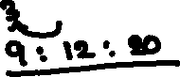

1. **A:B=3:4, B:C=2:3 and C:D=8:5. Find the ratio A:D**



**1.4:5 2.2:5 3.3:4 4.4:7 5.4:8**



1. **P:Q=2:3, Q:R=4:5, R:S=2:5, and S:T=3:4. Then P:Q:R:S:T is**

**1.32:48:60:150:225 2.16:24:30:75:225**



**3.24:36:45:75:100 4.16:24:30:75:100**



**5.32:58:30:60:250**



1. **A hostel with 300 students has provisions for 45 days. After 15 days, 150 students joined. How long will the provisions last now?**



**1.10 days 2.12 days 3.20 days 4.18 days**

**5.22 days**

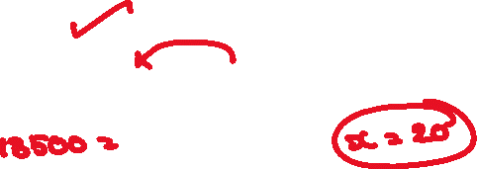

1. **120 turns each of 16 lts buckets are required to fill a tank. If 24 lts bucket is used, how many turns will be required**

**1.60 2.75 3.80 4.96 5.180**



1. **24 rows consist of 30 students each. If the arrangement is altered now with 6 more students in each row, the number of rows will be decreased by**



**1.20 2.6 3.8 4.4 5.9**

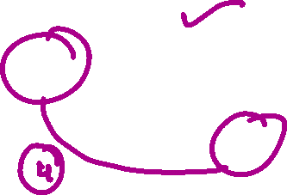

1. **A solution of 36 lts contains 10% sugar. If 6 lts of the solution is evaporated. Find the % of the sugar in the final solution**

**1.12 2.15 3.16 4.13.5 5.16**

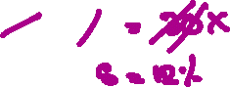

1. **A sugar solution of 30 lts contains 80% water. If 20 lts of water is added. Find the % of water in the resulting mixture**



**1.12 2.20 3.80 4.88 5.40**

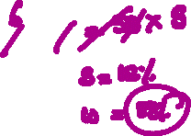

1. **In a map the scale is represented as 1:1000000. If the distance between two towns is 27.5 cm in the map, what is the actual distance between them in km?**



**1.250 2.275 3.300 4.325 5.350**

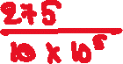

1. **A & B together have 275/-. 1/5 of A’s money is the same as 1\6 of B’s. What is the amount of money with A?**



**1.99 2.116 3.125 4.150 5.200**

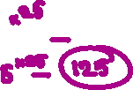

1. **A & B together have 18810/-. 4 times A’s amount is the same as 5 times B’s amount. What is the amount with B?**

**1.8360 2.10450 3.12000 4.13320 5.24000**



1. **A vessel of 125 lts capacity is full of pure milk. On the first day, 2/5 of the milk is drawn and filled with water. On the second the day 2/5 of the mixture is drawn and filled with water and again the same thing is done on the third day. Find the quantity of milk at the end.**



**1.25 2.27 3.30 4.35 5.40**

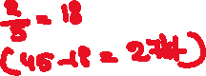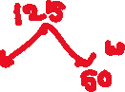

1. **A vessel of 24 lts is full of pure alcohol. For the first time, 1/3 of alcohol is replaced by water and for the second time, ¾ of the mixture is replaced by water. Find the quantity of water at the end**



**1.4 2.5 3.20 4.21 5.12**

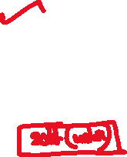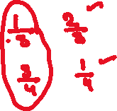

1. **In a class of 48 boys & girls are in the ratio of 3:1. Find the number of girls to be added to make the ratio 2:1**



**1.4 2.5 3.6 4.8 5.10**

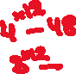

1. **Two vessels of equal capacity contain milk and water in the ratio of 2:3 and 3:5. If these are blended, find the ratio of milk and water in the resulting mixture**



**1.13:49 2.31:94 3.33:94 4.31:49**



**5.13:26**



1. **An amount of 1,96,500/- is divided among 360 boys and girls so that each boy gets 500/- and each girl gets 650/-. The number of boys is**



**1.140 2.180 3.220 4.250 5.240**



1. **25 chairs cost as much as 42 stools, 35 stools cost as much as 18 tables, 10 tables cost as much as 12 benches and a pair of benches costs 625/-. Find the cost of a chair**



**1.234 2.324 3.432 4.342 5.348**

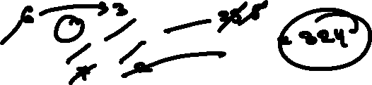

1. **In a box, there is one rupee, 50 paise, and 25 paise contained in the ratio of 3:4:5 and the total amount is 150/-. Find the number of 50 paise coins.**



**1.96 2.100 3.120 4.160 5.200**



1. **Two numbers are in the ratio of 4:5. If 12 is added to each number, the ratio will become 16:19. Find the difference**

**1.6 2.8 3.9 4.12 5.18**

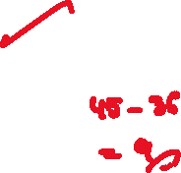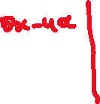

1. **Find the ratio in which a solution of 40% alcohol be mixed with a solution of 72% alcohol to get a mixture of 60% alcohol**

**1.3:5 2.2:5 3.3:4 4.2:3 5.3:6**



1. **How many kgs of rice costing 12/- a kg be mixed with 22 kgs of rice costing 18/- a kg to get a mixture costing 16.40/- a kg**



**1.6 2.8 3.10 4.12 5.4**

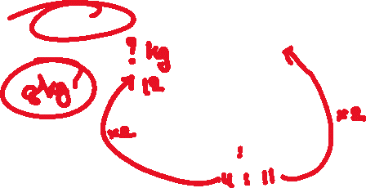

1. **Metal A is 23 times as heavy as water and metal B is 17 times as heavy as water. In which ratio should these be melted together to get an alloy that is 19.75 times as heavy as water?**



**1.11:13 2.11:14 3.12:19 4.4:9**



**5.11:15**



1. **The value of a precious stone varies as the square of its weight. Such a stone is broken into two pieces of weight in the ratio 2:3. As a result its total worth was reduced by 93,600. What was its original worth?**



**1.1,80,000 2.1,77,000 3.1,64,000 4.1,60,000**

**5.1,95,000**

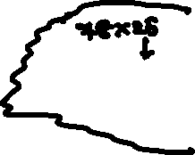

1. **An amount of 17,750/- is distributed among A, B & C. After they spend 150/-, 200/-, 300 their respective shares will be in the ratio 8:6:5. What is the total amount distributed to A?**



**1.7,350 2.9,300 3.11,500 4.10,200**



**5.12,200**

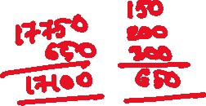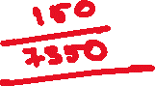

1. **An amount of 46,800/- is to be distributed among A, B and C in the ratio 1/2:1/3:1/4. By mistake it is distributed in the ratio 2:3:4. In the transaction amount lost by A is**

**1.10,200 2.10,800**

**3.11,200 4.12,100**

**5.12,200**